GROOMING YOUR HORSE
Reasons for Grooming
There are several reasons to groom your horse:
- To clean him and make him look nice and feel comfortable.
- To check him over carefully for injuries or skin problems.
- To prevent sores from dirt under the tack when you ride him.
- To condition his skin and make his coat shine.
- To promote good circulation of the blood.
Your horse should be groomed or at least checked over every day, whether he ridden or not. He must be cleaned before he is saddled to prevent dirt from causing saddle and girth sores, and he should be brushed smooth after he has been ridden. The best time to groom a pony thoroughly is after he has been ridden, when his skin is warm.
GROOMING TOOLS
Your grooming tools should be kept together in a grooming kit.
The basic grooming tools include:
- Currycomb (rubber or plastic): for loosening caked mud and dirt and rubbing the horse's skin. It should be flexible, not too hard and sharp. (Metal currycombs should only be used for cleaning the body brush. They are too sharp to use on a horse's skin.)
- Dandy brush or stiff brush: for removing heavy dirt and dried mud. Good for long coats and pastured horses.
- Body brush or soft brush: has short bristles set close together, to remove dirt, dust and scurf (dried sweat and dandruff) from the coat and skin. Best tool to really get a horse clean!
- Hoof pick: For picking out the feet.
- Hoof brush: Small stiff brush for cleaning the feet ( a scrub brush works well). Some hoof picks have a hoof brush at one end.
- Sponges: Two smaller ones, for cleaning eyes, nose, lips and dock. Use different colors or shapes for face and dock sponges, so they won't get mixed up. A larger sponge is used for washing the pony. (Off brand baby wipes are also great for cleaning the horses face and are very inexpensive and disposable.)
- Mane comb or hairbrush: for untangling the mane and tail (after picking out tangles with your fingers). (Metal mane combs are not recommended, because they break off too many hairs.)
- Stable rubber or towel: for removing stains, or for a final polish after grooming. Also good for rubbing out sweat marks.
- Water brush: for wetting down the mane and tail and scrubbing away stains. (This can be a plastic scrub brush from the grocery store, or a special brush made for this purpose.)
There are some other things you may want to keep in your grooming kit, like disposable cotton balls for cleaning the eyes and nose, a Styrofoam scraper block for removing bot-fly eggs, hoof dressing and a brush to paint it on with, "cactus cloth" (a special grooming cloth for removing stains) and fly repellent.
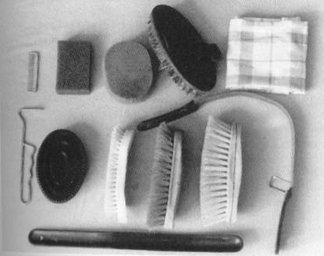
Contents of grooming kit: Top, left to right: mane comb, face sponge, dock sponge, body brush, and rub rag. Center, left to right: hoof pick, rubber curry comb, plastic scrub brush (substitute for water brush), dandy brush, water brush, shedding blade. Bottom: sweat scraper.
How to Groom a Horse
Before you start to groom your horse, he should be tied up correctly in a safe place. Don't try to groom a pony when he is loose in a stall or not wearing a halter. If he tries to turn around or get away, you will have no control.
Pick out his feet with the hoof pick. Use the hoof pick from heel to toe, so you won't accidentally dig it into the frog (the softer center part of the hoof). Clean the cleft of the frog ( the groove down the middle), and the spaces on each side of the frog. Use a hoof brush to brush the foot clean, so you can check it thoroughly. Check that each shoe is tight and the clinches (the bent-over ends of the nails) are smooth.
Use the rubber or plastic currycomb to rub the skin in circles or side to side, starting at the top the neck and working back down. Go easy on sensitive places. This tool breaks up caked mud, loosens scurf, and rubs and stimulates the skin, but it can be too harsh for some horses. Don't use a curry comb on the head, lower legs or anyplace that is especially sensitive.
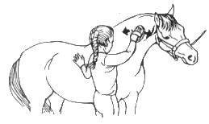
Using currycomb: rub side to side or in a circle.
Starting at the top of the neck, brush the coat with the dandy brush, in the direction the hair grows. Use short, snappy strokes to get down to the skin and flick the dirt out. The dandy brush takes away the larger bits of dirt loosened by the curry comb. You can use this brush on the body, neck and legs, and on the head if your horse doesn't mind. If your horse is very sensitive or he has been clipped, the dandy brush may be too harsh for him.
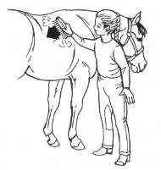
Using dandy brush: short, firm strokes the way the hair grows.
The body brush is used to clean away dirt, dust and scurf from the skin. Use short, firm strokes the way the hair grows, with firm pressure to get between the hairs, right down to the skin. After every few strokes, clean the body brush by scraping it across the teeth of a metal curry comb, or use the dandy brush to clean it. This way, the dirt goes into the brush and then out into the air, not back on the horse. You can use the body brush all over your horse's body, head and legs. It is the best brush for getting the coat really clean and shiny. Because it is soft, it can be used on clipped horses or those with sensitive skin.
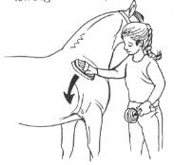 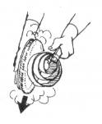
Using the body brush: short, firm stokes the way the hair grows. Clean body brush every few strokes w/ currycomb.
The mane and tail should be carefully picked free from tangles, taking just a few hairs at a time so you don't break off or pull out hairs. Part the hair and use the body brush to clean the skin and the roots of the hair, one section at a time.
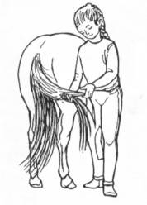
To be safe when you work on the tail, stand to one side, not right behind the horse.
A stable rubber or folded towel is used to bring out the shine of the coat. Bear down and rub firmly across and with the direction the hair grows. Firm rubbing warms up the skin and spreads the skin oils over the hair, making the coat sleek and shiny.
Use a damp sponge or a disposable cotton ball to clean the eyelids, nostrils and muzzle. You can also gently clean inside the ears. Use another sponge to clean underneath the tail and around the sheath or udder.
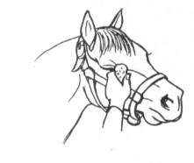
Wipe eyelids, lips and muzzle with damp sponge. Use another sponge to clean the dock.
If your horse still has manure or grass stains after you finish grooming, these can be removed by rubbing the spots with a damp towel, by shampooing them or by rubbing them out with a cactus cloth.
HAPPY GROOMING AND HAVE FUN!

